[PWS System Name]
Emergency Response Plan (ERP)
This document complies with AWIA Section 2013 requirements.

Water System Information
Keep this basic information readily available for when you need it for emergency responders, repair people, and the news media.
System information
Public Water System identification number | NM35
Street Address | City, State, Zip Code
Phone Number Office | Phone Number Mobile
Population served and service connections | Population |  | Connections
System owner (the owner should be listed as a person’s name)
Name, title, and phone number of person responsible for maintaining and implementing the emergency plan | Name | Title |  | Phone  Cell:  Office:
ERP Prepared by:
ERP Reviewed by:
Date Completed

Change History
Please describe the changes made to this plan since its original development, who made the changes and on what date the changes were incorporated into this plan.
description of change | NAME/TITLE | Date

TABLE OF CONTENTS
UTILITY INFORMATION 4
- Utility Overview 4
- Personnel Information 5
- Primary Utility Components 6
- Industry Chemical Handling and Storage Facilities 8
- Safety 9
- Response Resources 10
- Key Local Services 10
1 RESILIENCE STRATEGIES 11
- 1.1 Emergency Response Roles 11
- 1.2 Incident Command System (ICS) Roles 13
- 1.3 Communication 14
1.3.1 Internal Communication 14
1.3.2 External Response Partner Communication 15
1.3.3 Critical Customer Communication 16
1.3.4 Communication Equipment Inventory 16
- 1.4 Media Outreach 17
- 1.5 Public Notification Templates 17
2 EMERGENCY PLANS AND PROCEDURES 18
- 2.1 Core Response Procedures 18
- 2.2 Incident-Specific Response Procedures 22
3 MITIGATION ACTIONS 23
- 3.1 Alternative Source Water Options and Interconnected Utilities 23
- 3.2 Other Mitigation Actions 24
4 DETECTION STRATEGIES 25

Utility Information
During an incident, you need to have system information about your water utility readily available for your personnel, first responders, repair contractors/vendors, the media, and other response partner agencies.

1) Utility Overview
Public Water System identification number | NM35
Street Address | City, State, Zip Code
System owner (the owner should be listed as a person’s name)
Directions to utility from major roadway, include lat./long. coordinates
Population served and service connections | Population |  | Connections
Name, title, and phone number of person responsible for maintaining and implementing the emergency plan | Name | Title |  | Phone
Alternate Contact
Location of treatment, distribution, collection schematics and operation manuals

Use this checklist to ensure the following additional utility information (as applicable) is included as a part of your ERP.
☐ Map of distribution systems
☐ Pressure boundary map
☐ Process flow diagram
☐ Site plans and “as built” drawings for the following components of your system (as applicable):
  - Pumping and storage facilities
  - Reservoir facilities
  - Water treatment facilities
  - Chemical storage locations
  - Booster pump stations
  - Pressure-regulating valve (PRV) sites
☐ Distribution system diagrams and instrumentation information
☐ Equipment specifications and operation instructions
☐ Emergency power and light generation operation specifications
☐ Supervisory Control and Data Acquisition (SCADA) system operation instructions
☐ Communications systems operation instructions

2) Personnel Information
Attach your personnel roster here or fill out the table below.
Personnel
Name and Title | Job Duties and Responsibilities | Phone Number | Emergency Information

3) Primary Utility Components
List all the components necessary to maintain effective operation of your utility. Add more rows to the tables below if you have additional components. Text in italics represents examples – be sure to delete italicized text as necessary as you fill out the tables below and throughout this template.

Wells
Well Name | Depth/Location | Available Yield | Treatment Requirements/Associated Treatment Plant

Intakes (Surface Water Systems-Only)
Intake Name | Depth/Location | Capacity | Treatment Requirements/Associated Treatment Plant

Treatment Plants
Plant name | Location | Capacity | Treatment Type

Storage and Distribution System – Tanks, Primary Mains and Pumping Stations
Location | Area Served | Comments

Treatment Chemical Storage Facilities (Tier II reporting MAY be required)
Location | Chemical & Quantity | Comments
Pump House #1 | Chlorine | This is in liquid form and there is both an eye wash and shower station in the pump house

- NOTE: Tier II chemicals are reportable for regulated facilities under the Emergency Planning and Community Right-to Know Act of 1986 (EPCRA Section 312). Tier II reporting requires that facilities submit an annual inventory of hazardous chemicals onsite that exceed threshold planning quantities. Tier II reporting includes any substance for which a facility must maintain a Safety Data Sheet (SDS) under the OSHA Hazard Communication Standard (29 CFR 1910).
- The Consolidated List of Lists: https://www.epa.gov/epcra/consolidated-list-lists
Prepared to help facilities handling chemicals determine, for a specific chemical, whether they may be subject to certain reporting requirements. These lists should be used as a reference tool, not as a definitive source of compliance information.
- Tier II General Forms & Instructions: https://www.epa.gov/epcra/tier-ii-forms-and-instructions
- Specific NM Tier II Reporting Requirements:
State Tier II Reporting Requirements and Procedures | US EPA

Other Key Facilities
Location | Function | Comments

4) Industry Chemical Handling and Storage Facilities
List surrounding chemical production, handling or storage industries that could impact your utility during incidents such as accidental releases, fires, or earthquakes.

Industry Chemical Handling Facilities
Facility Name | Location | Distance | Chemical and Exposure Pathway
Shiny Stuff Factory | 54 Grove Street | 0.15 miles to the north of the utility admin building | Facility uses large amounts of highly volatile chemicals. If power failure occurs, evaporation of these chemicals may occur, causing air pollution in areas surrounding the factory.

Chemical Storage Tanks
Facility Name | Location | Distance | Chemical and Exposure Pathway
Metro Gas Station | 25 Main Street | 0.2 miles west of the utility wellfield | 20,000-gallon underground storage tank (UST) holding gasoline. Earthquakes may cause disruption or leaking of the tank.

5) Safety
List safety materials and important safety information to help protect utility personnel during an incident. You may also reference your utility Health and Safety Plan, if available.

Safety Materials
Type | Location
Toxic material detection and testing supplies
Emergency food and water supplies
Emergency PPE (note what PPE are present at each location)
Other equipment (note what is present at each location)

Safety Information
Topic | Description
Wind speed | Utility personnel may not work outdoors when the sustained wind speed is 45 mph or greater.

6) Response Resources
Provide an inventory of available resources (e.g., equipment, supplies) either maintained on site or readily available off site (e.g., neighboring water system) in the table below, or insert an existing inventory sheet.
Resources
Kind | Type | Quantity | Location
Generator
Fuel
Pump
Other

7) Key Local Services
Note the closest locations of key logistical and medical services that you or mutual aid and assistance providers may need during an incident. Include a map if available.
Essential Services
Facility | Location/Description
Hospital
Gas station
Pharmacy
ATM
Grocery store
Other service

1 Resilience Strategies
This section contains strategies and resources to improve the resilience of the system, including physical and cybersecurity.

1.1 Emergency Response Roles
Describe the roles and responsibilities for key internal utility personnel and external response partner personnel in the tables below.
Water Utility Personnel – Internal Responsibilities
Name/Title | Emergency Response Role | Responsibilities
Wendy Smith/ Superintendent | Emergency Response Lead | Responsible for all incident response activities, including developing strategies and tactics and ordering and releasing resources.
John Doe/Operations Chief | Alternate Emergency Response Lead | Perform duties as assigned by ER Lead; assumes duties listed above when ER Lead is not available.
Jim Rogers/County Public Affairs Officer | Public Information | Responsible for leading the public information effort based on information supplied by either the ER or Alternate ER Lead.
Jane Kelly/Chief of Police | Security | Will provide incident security as needed once notified by ER Lead.
Other | Other | Other

External Response Partner Roles
Name/Title | Organization | Responsibilities During an Incident
Local Partners
 | Local Law Enforcement
 | Fire Department
 | Ambulance Service
 | Health Department
 | Neighboring Water Utility
 | Power utility
 | Other
State Partners
 | NMED Drinking Water Bureau
 | Health Department
 | State Police
 | NM WARN
 | Laboratories
 | Other
Federal Partners
 | EPA Regional Office
 | FBI Field Office
 | CDC
 | Other

1.2 FEMA Incident Command System (ICS) Roles
The Federal Emergency Management Agency (FEMA) helped develop the Incident Command System (ICS). ICS is a standardized approach to emergency management that is used for all types of incidents, both natural and human-made, by all types of organizations. ICS is applicable to small and large complex incidents. ICS is designed for all agencies to be able to communicate and function together during an incident using common language and an organized structure.
An ICS Incident Organization Chart (ICS Form 207) (example below), available at FEMA’s ICS Resource Center, may be completed for your utility and inserted here or attached to your ERP. Not every incident will require all the personnel listed on ICS Form 207. At a minimum, identify your personnel who are required to respond to your water system emergencies, and identify the role(s) they are required to fill. Make sure you share this information with your personnel.
Community water systems are encouraged to train in ICS Emergency Management Institute - National Incident Management System (NIMS) (fema.gov). ICS-100: Introduction to the Incident Command System is a good starting point to understand this emergency management approach.

Incident Organization Chart (ICS 207)
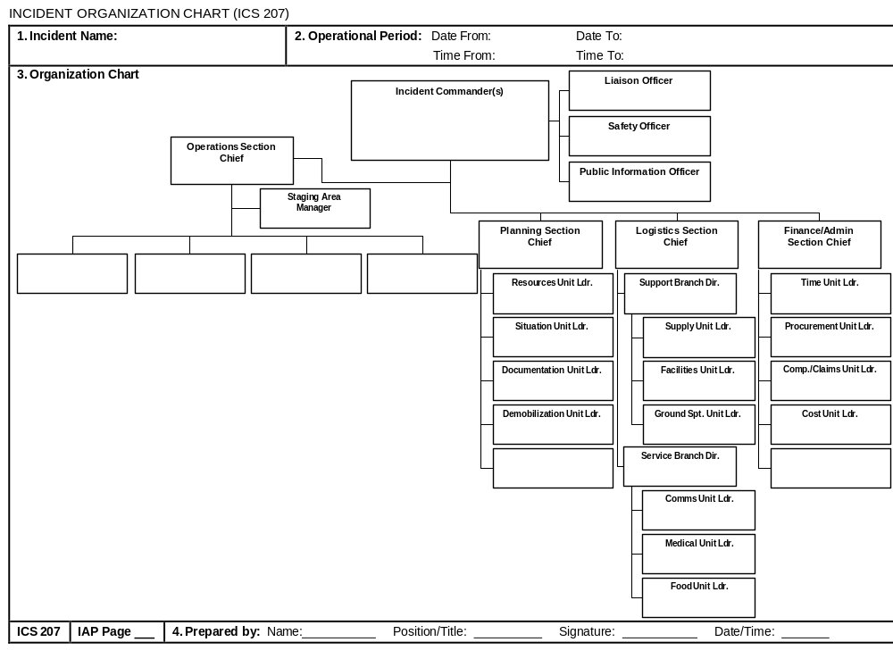

1.3 Communication
Communication during an incident is critical to relay information to employees, response partners and critical customers about potential risks to health, infrastructure, and the environment.

1.3.1 Internal Communication
List all PWS emergency response team members, their response role, title and contact information.
Contact List
Name | Role/Title | Phone | Alternate Phone | Email

1.3.2 External Response Partner Communication
List all external response partners, their response role or position as well as contact information.
External Response Partner Contact List
Organization or Department | Point Person Name or Position | Phone | Alternate Phone | Email or Website
Local Partners
Local Law Enforcement
Fire Department
County Emergency Management
Ambulance Service
Health Department
Neighboring Water utility
Power utility
Wastewater Utility
Elected Officials
Contractor/Vendor
Other Partners
NMED Drinking Water Bureau
Health department
State Police
NM WARN
Laboratories
Other
Federal Partners
EPA regional office
FBI field office
CDC
Other

1.3.3 Critical Customer Communication
List critical customers below who should be given priority notification due to their reliance on the water supply either for medical reasons, based on usage, public health mission or because they may serve customers considered to be sensitive sub-populations.
Critical Customer Contact List
Organization or Department | Point Person Name or Position | Contact Instructions | Phone | Alternate Phone | Email or Website
Wholesale customer
Senior living center
Nursing home
Hospital
Dialysis clinic
Hotel
Transportation center
School
University
Daycare center
Factory
Government building
Large water user
Other

1.3.4 Communication Equipment Inventory
Inventory your utility’s communication equipment below.
Communication Equipment
Type | Assigned to | Location | Number/Frequency/Channel

1.4 Media Outreach
List contact information for all media outlets that your utility may coordinate with during notification efforts. Additionally, include existing risk communication procedures, such as composing and delivering messages (e.g. message mapping), or reference an existing Risk Communication Plan.
Contact List
Organization or Department | Point Person Name & Position | Phone | Alternate phone | Email or Website
Utility social media coordinator
Newspaper - Local
Newspaper – Regional/State
Radio station
TV station
Advertising agency
Other
Other

1.5 Public Notification Templates
Insert your templates for public notifications here, or reference where they may be found. Ensure that your templates are consistent with the regulatory requirements for public notification contained in the Public Notification Rule (see 40 CFR 141, Subpart Q) and all relevant state regulations.

2 EMERGENCY PLANS AND PROCEDURES
This section contains plans and procedures that can be implemented in the event of a malevolent act or natural hazard that threatens your utility’s ability to deliver safe drinking water.

2.1 Core Response Procedures
Core procedures are the “building blocks” for incident specific response procedures, as they are typically implemented across a broad variety of incidents (e.g., fire, flood, earthquake). List all your core procedures here.
Access
Item | Description
Debris clearing | List or reference here any supplies or equipment your utility owns to help with debris clearing; this includes safety items/personal protective equipment, chainsaws, and debris/earth moving equipment. If you do not have it, list where you will get it from.
Alternate routes | List or reference here alternate routes (e.g., if there is a bridge that connects your community, what are your travel options if the bridge becomes impassable?). If the alternate routes are too long, consider staging similar critical equipment and resources in different areas of your community.
Identification badges | Provide personnel with an official utility ID for access through police barricades or hazmat contaminated zones. If your jurisdiction has an identification program for first responders, be sure to participate.
Other

Physical Security
Item | Description
Access control procedures | List or reference your facility access control procedures here, such as key cards are required to access all buildings. Also, list any lockdown procedures as appropriate as well as the process for establishing a security perimeter following a major incident.
Restricted areas | List or reference any restricted areas of your facilities here, such as chemical rooms and electrical closets. Also list who may access those areas.
Evidence protection measures | Describe or reference your procedures for working with law enforcement if an incident is declared a crime scene.
Security culture | Increase organizational attentiveness to security to help reduce vulnerability and enhance preparedness. For example, a “See Something, Say Something” campaign for your utility. List measures your utility implements here.
Other

Cybersecurity
Item | Description
Disconnect procedure | If possible, disconnect compromised computers from the network to isolate breached components and prevent further damage, such as the spreading of malware.
Notification | List who should be called in the event of a cyber incident, such as your utility information technology (IT) supervisor or your contracted IT service provider. Also list any external entities that may have remote connections to your network.  Include any state resources that may be available such as State Police, National Guard Cyber Division or mutual aid programs, as well as the Department of Homeland Security National Cybersecurity and Communications Integration Center (NCCIC) (888-282-0870 or NCCIC@hq.dhs.gov).
Assess procedure | Assess any damage to utility systems and equipment, along with disruptions to utility operations.
Implementation processes | Implement actions to restore operations of mission critical processes (e.g., switch to manual operation if necessary) and provide public notification (if required).
Documentation | Include forms to document key information on the incident, including any suspicious calls, emails, or messages before or during the incident, damage to utility systems, and steps taken in response to the incident (including dates and times).
Other

Power Loss
Item | Description
Backup power systems | List or reference your auxiliary power sources (fixed and portable) if you have not already done so elsewhere in your ERP. Provide a summary of critical facility power requirements, generator siting requirements, and the location and capacity of any existing on-site generators at all critical infrastructure components.
Power utility | Coordinate with your power utility for expected restoration priorities and timing. Power utility contact information should be listed in Section 3.2 above.
Fuel plan | Provide an inventory of on-site fuel supplies and list or reference your procedures to obtain additional fuel from vendors for your backup generators during an incident.
Maintenance plan | Maintaining generators during extended outages is critical. List your maintenance procedures for each generator, who is responsible for implementation and include lists of on-hand items such as spare parts and filters.
Other

Emergency Alternate Drinking Water Supplies*
Item | Description
Bottled water | Provider name:  Phone:  Contract No. (if applicable):  Available supply:  Distribution point (notify public of location):
Bulk water (check with your state first for licensed water haulers) | Provider name:  Phone:  Contract No. (if applicable):  Available supply:  Distribution point (notify public of location):
* Interconnections are listed and described in Section 3.1

Sampling and Analysis
Item | Description
Sampling procedures | Identify proper sampling procedures for different types of contaminants and attach those procedures to your ERP or reference where they can be found. Determine the quantity of required samples.
Pre-identified sampling locations | While some sampling sites will be dictated by the emergency, you can pre-plan your ideal sampling locations such as tanks and reservoirs or entry and exit points from pressure zones.
Sampling containers and preservatives | Obtain and inventory all sample containers and preservatives and list or reference them here.
Sample collection | Confirm who will be responsible for sample collection during an emergency and who can take over if that person is not available. List those names here.
Sample transportation | Confirm who will be responsible for transportation during an emergency and who can take over if that person is not available. List those names here.
Laboratory capabilities | Confirm what contaminants can be analyzed and your lab’s surge sampling capacity. It may be helpful to have several backup laboratories in case your utility’s lab or preferred contract lab are overwhelmed with high sample volume. Identify contract laboratories in the following table.
Interpreting results | Work with the appropriate lab, utility and regulatory agency personnel to interpret sample results. List those names here.
Other

Local Contract/State/Federal Laboratory Contact List
Name | Address | Analytes/Methods | Phone | Email or Website
 |  | Metals, VOCs and SVOCs

Family and Utility Personnel Well Being
Item | Description
Family disaster plan | Implement your family plan to ensure their well-being during an incident.
Assembly area | List all the assembly areas and evacuation procedures for personnel.
Supplies | List the supplies necessary to maintain personnel health and well-being during an incident (e.g., food, potable water, cots, first aid kit, sanitary products).
Alternate work and shelter locations | Personnel may need to work from home. Or, they may need to shelter at a hotel or your utility if conditions do not permit travel home. List conditions for which work at home provisions will be triggered and list sheltering locations and procedures here.
Extreme temperatures | List or reference here any supplies or equipment your utility owns to mitigate extreme temperatures such as cold weather items (e.g., sand, salt, ice melt, tire chains, snowshoes) and hot weather items (e.g., pop-up shade canopies, water coolers, broad-brimmed hats).
Other

2.2 Incident-Specific Response Procedures
Insert applicable Incident-Specific Response Procedures (ISRPs), specialized procedures tailored to an incident type. Incidents may include, but are not limited to, the following:
- Cybersecurity  - Drought  - Earthquake  - Extreme Cold and Winter Storms  - Extreme Heat  - Flooding  - Harmful Algal Bloom | - Hurricane  - Tornado  - Tsunami  - Volcanic Activity  - Wildfire  - Source Water Contamination  - Distribution System Contamination
EPA’s website provides a number of incident action checklists (IACs) that you can use to help develop your own ISRPs. EPA also published the Prepared for Contamination in Your Distribution System? guidance that can help you develop a distribution system contamination ISRP.

3 MITIGATION ACTIONS

This section contains actions, procedures, and equipment which can obviate or significantly lessen the impact of a malevolent act or natural hazard on the public health and the safety and supply of drinking water provided to your community and individuals, including the development of alternative source water options, relocation of water intakes, and construction of flood protection barriers.

3.1 Alternative Source Water Options and Interconnected Utilities
List information on alternative source water options and interconnected utilities to mitigate impacts during incidents.
Alternative Source Water Options
Type | Location | Comments
Well | Municipal golf course | This irrigation well can be used to supply water under emergency approval from state. Chlorination is needed and the well can produce up to 300 gpm.

Interconnected Utilities
Utility Name | Location | Contact Information | Comments
ABC Water | Town next door | Jane Doe: 555-555-1234 | Plans on file in engineering to construct emergency connection if needed.

3.2 Other Mitigation Actions
List any mitigation procedures or projects implemented at your utility, such as raising facilities and controls or constructing berms to protect against flood damage.
Mitigation Actions
Type | Location | Comments
Water intake relocation | Intake 1 | This intake was moved further offshore and deeper to better avoid surface spills and low river levels during drought
Watertight doors | Treatment plant | These doors were installed to help ensure floodwaters cannot enter the treatment building and damage control systems
Earthquake | All facilities | Anchored equipment (e.g., computers, bookshelves) as well as laboratory equipment and chemical and fuel tanks

4 DETECTION STRATEGIES
This section contains strategies that can be used to aid in the detection of malevolent acts or natural hazards that threaten the security or resilience of the system.

List the detection strategies and methods your utility uses to aid in the detection of malevolent acts or natural hazards. Also list the corresponding procedure to be used if the threat is detected.
Detection Strategies
Threat | Detection Method | Procedure
Unauthorized entry | - Alarm from intrusion detection system | Call 911
Source water contamination | - National Response Center notifications  - Notification from 911 for releases resulting from transportation accidents | Source Water Contamination Incident Response Plan
Distribution system contamination | - Customer complaint surveillance  - Public health surveillance | Distribution System Contamination Response Procedure
Cyber intrusion | - Automated IT and operation technology (OT) system intrusion detection monitoring  - Notification from utility staff | Cyber Incident Action Checklist
Hazardous chemical release | - Chlorine gas in air monitors | Call fire department
Flood | - Notification from Army Corp | Flood Incident Action Checklist
Power outage | - Notification from energy provider  - Alarm from line power sensor | Generator Start-up Checklist
Other
Other

