APPLICATION RENEWAL

Initiate a renewal WWeP Application
Note: If you don’t see an application under renewal, please check if you have been approved for a role in the organization.
If you already have a permit or authorization expiring soon and you wish to renew, proceed as follows:
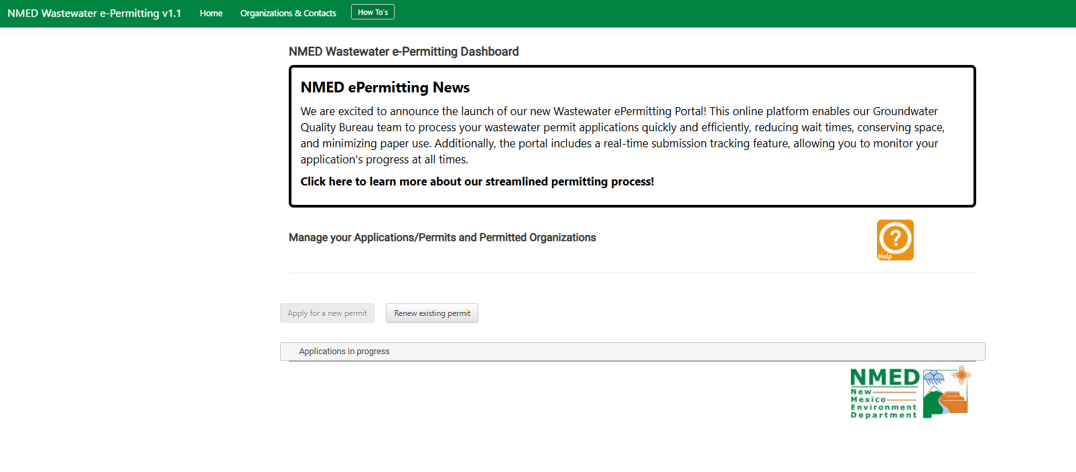
- From WWeP home, you will see a button labeled “Renew Existing Permit”
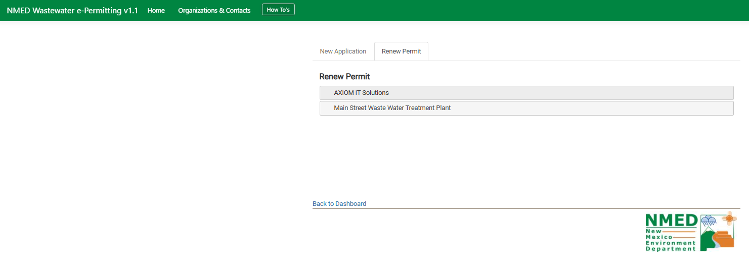
- Click on “Renew Existing Permit” and select and edit permit that is up for renewal.

