How to Create a NMED Wastewater e-Permitting Login
To create NMED Wastewater e-Permitting account, you will need to follow the following steps:
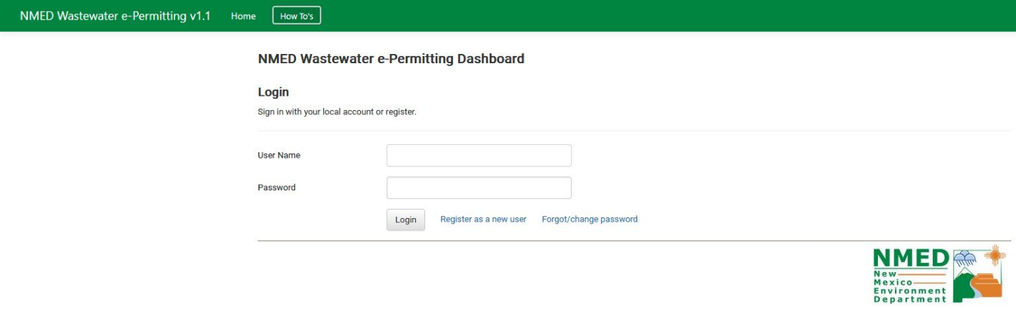
- Click on Register as a new user on the initial screen

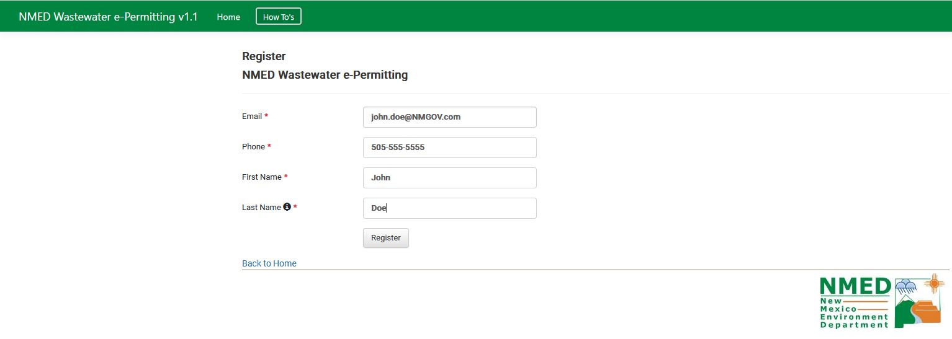
- Enter your details

- Click on Register

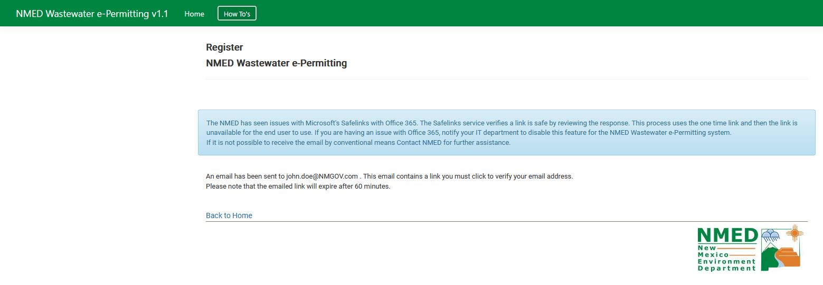
- An email will be sent to you with link for next steps. Please check your “Spam” folders as well.

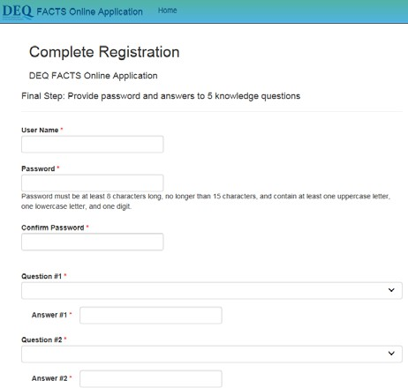
- Complete Registration Processes for new user account

NMED Wastewater e-Permitting

Enter desired user name, password. As a part of security requirement, please select five questions and their unique answers
