Preparing an NMED Discharge Permit Application
Note: You can leave the application process at any time to return later and pick up where you left off by viewing/editing your application. Your progress will be auto-saved.
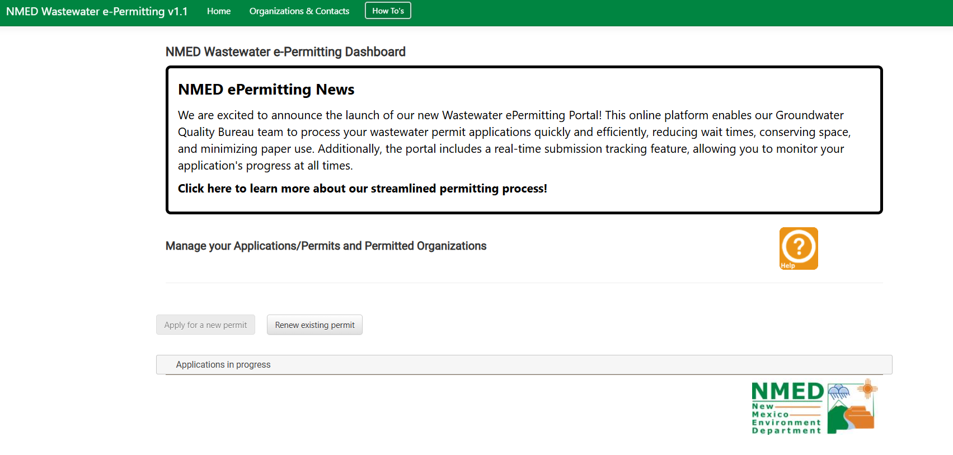
- Log in to WWeP. If your organization has a pending application, it can be found under the heading “Applications in Progress.”
- Click on the Facility Name or Permit # to edit the application
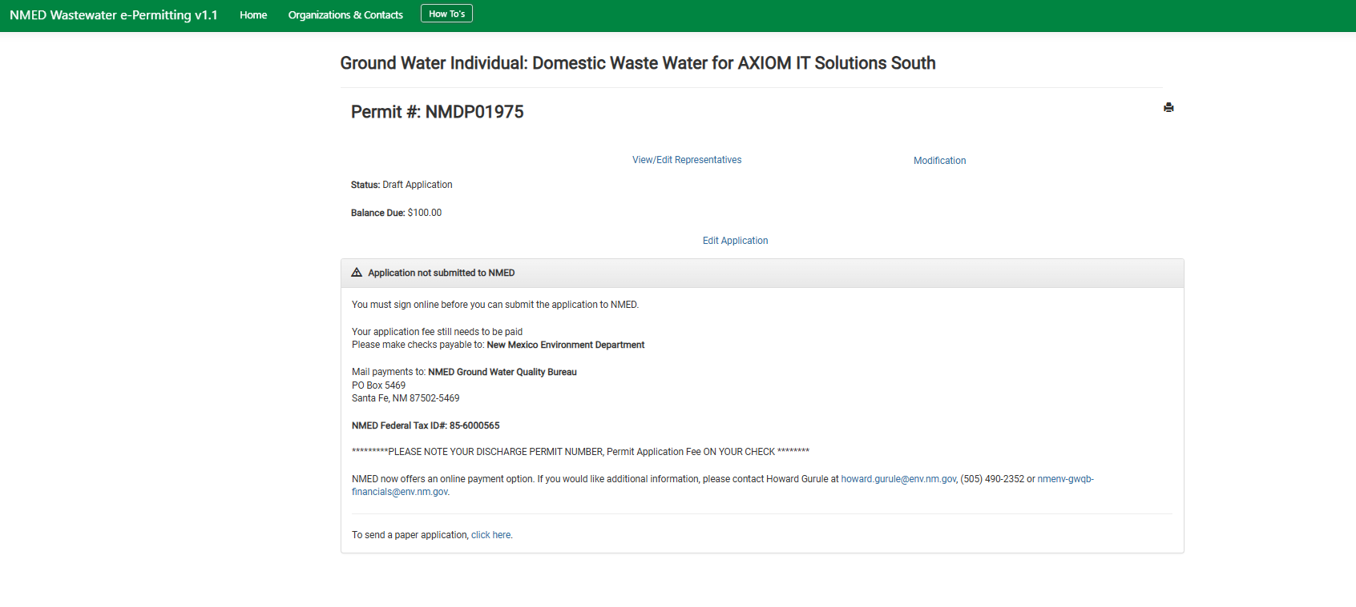
  - This will open the status page, which shows the facility’s outstanding application fee. The application can still be edited before the application fee is paid. Click “Edit Application to proceed to the application.
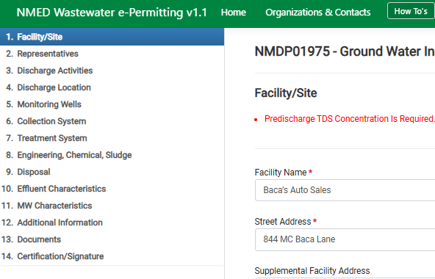
- Fill out required fields. Different steps in the permit application can be selected by the table of contents on the left side of the window:
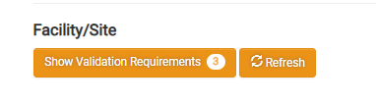
  - Required fields can be identified by the red asterisk next to the heading. If a page has more than one required field still to be filled out, the top of the page will show two buttons: “See Validation Requirements (#)” and “Refresh”.
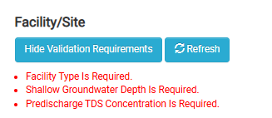
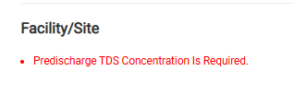
  - The number lets you know how many fields are still required on the page. Click the “See Validation Requirements” button to see a list of required fields that need to be completed. Once you fill out the fields, you can click the “Refresh” button to update the list and number. If there is only a single required field left to complete, that field will be displayed instead of the “See Validation Requirements” button.
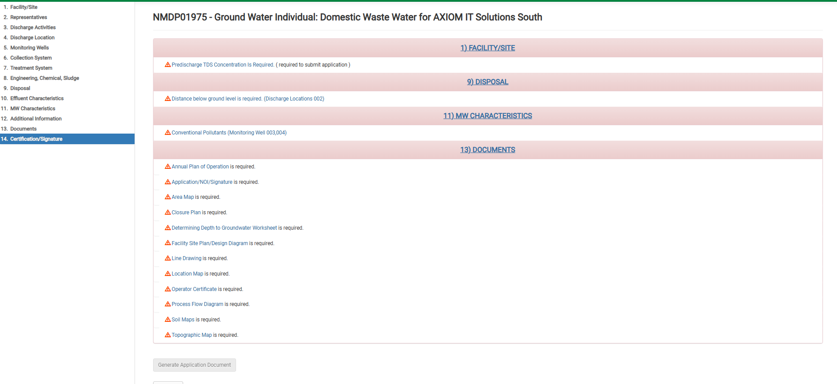
  - All required fields must be completed correctly to submit the application. At any time during the application process, you may skip to the last step (“Certification/Signature”) page on the left-hand side. This page will show you all the required information that has not been completed for each step of the application process. \
- Once you provide all the required information for the application and you submit it, you will be presented with a screen like the one below:

From this point, you have two more processes left:
- Sign the Application. This is the process of verifying and applying for the permit.
- Pay the required fees.

