How to Add a New Organization
To add a new Organization to a WWeP account, please follow these steps:

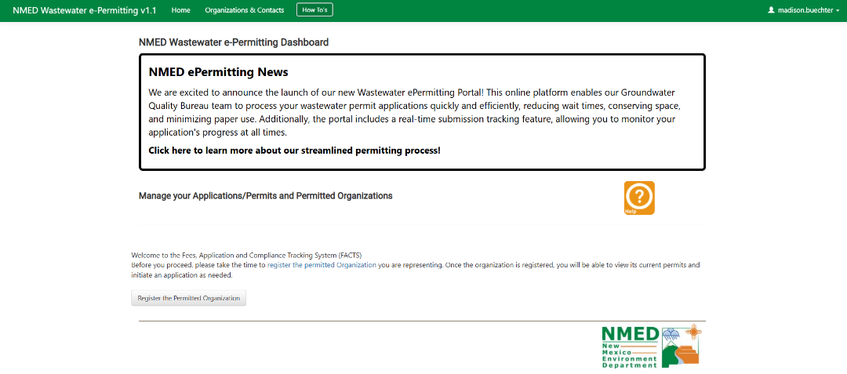
- If this is the first time you are logging in to WWeP, you will see a button to “Register the Permitted Organization.”

- Click “Register the Permitted Organization,” and it should lead you to the following screen:
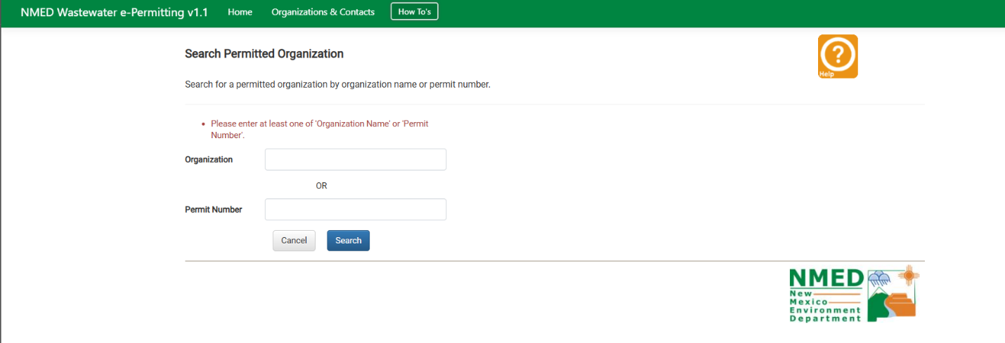

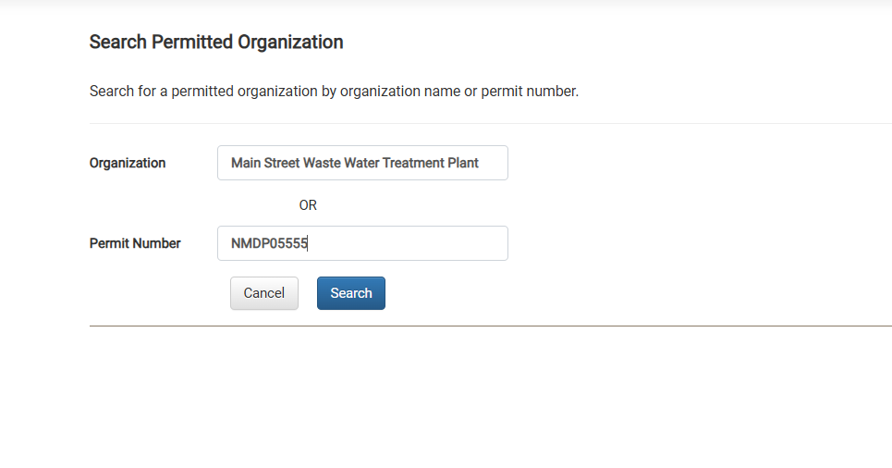
  - Search for your organization by typing the name in the “Organization” Field or the DP number in the “Permit Number” field (NMDP0####) and then clicking “Search”.

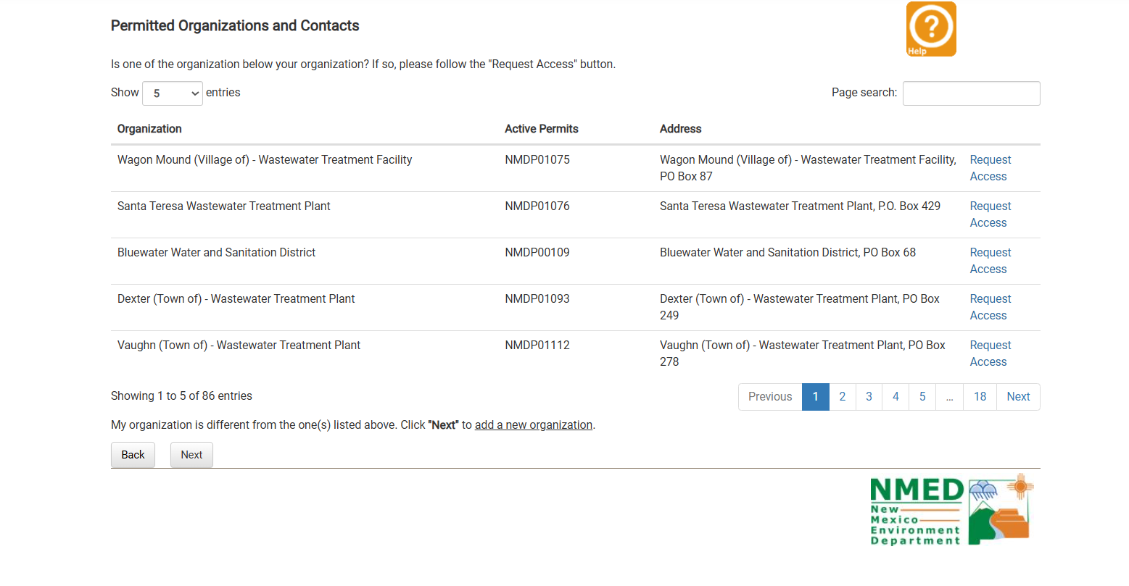
- If your organization does not exist in the WWeP system, you can add your organization by clicking “Next”.

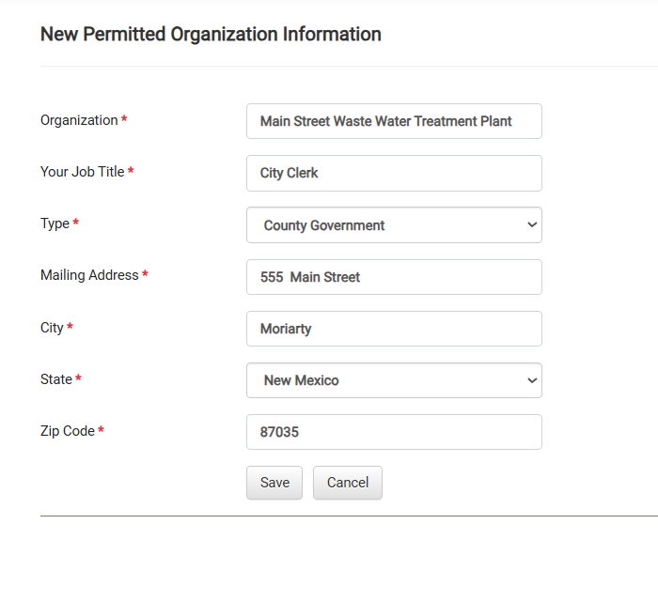
  - Fill out your organization’s mailing information on the next screen and click “Save:
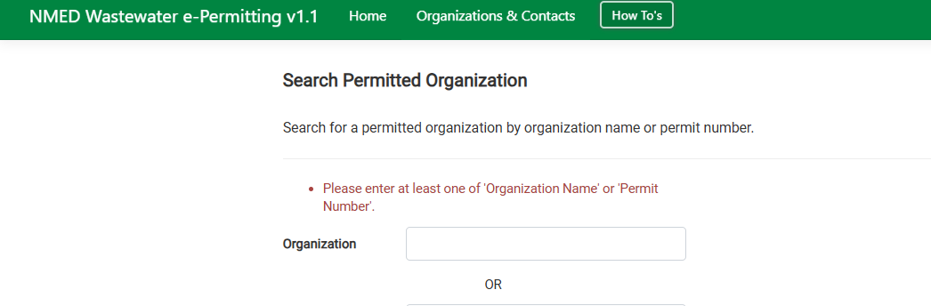
Please note that a New Organization can be added or modified at any time in the future by clicking “Organizations and Contacts.”

Request Access to an Existing Organization
Only Permitted entities have an organization in WWeP. Please follow these steps to Request Access to an Existing Organization as a Preparer.

- Use the “User Registration Management” instructions to create a WWeP account.
- Log in to WWeP
- Click “Register the Permitted Organization” on the “Home” page.

- Search for your organization by typing the name in the “Organization” Field or the DP number in the “Permit Number” field (NMDP0####) and then clicking “Search”.

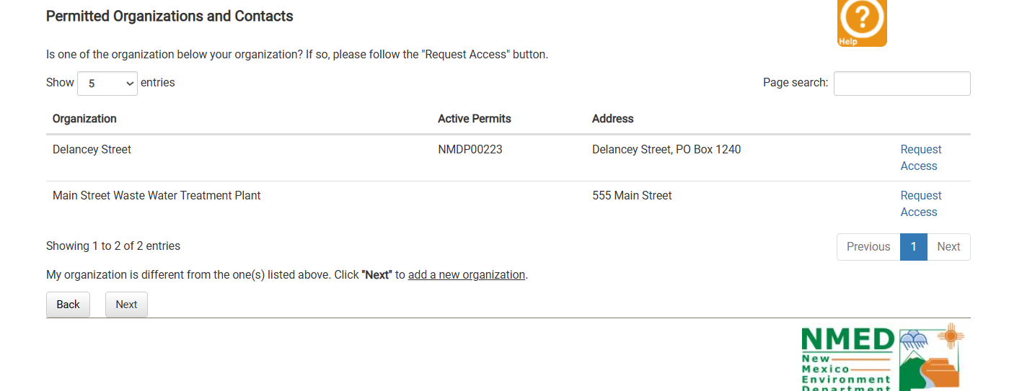
- Review existing organizations already entered in WWeP and Request Access.

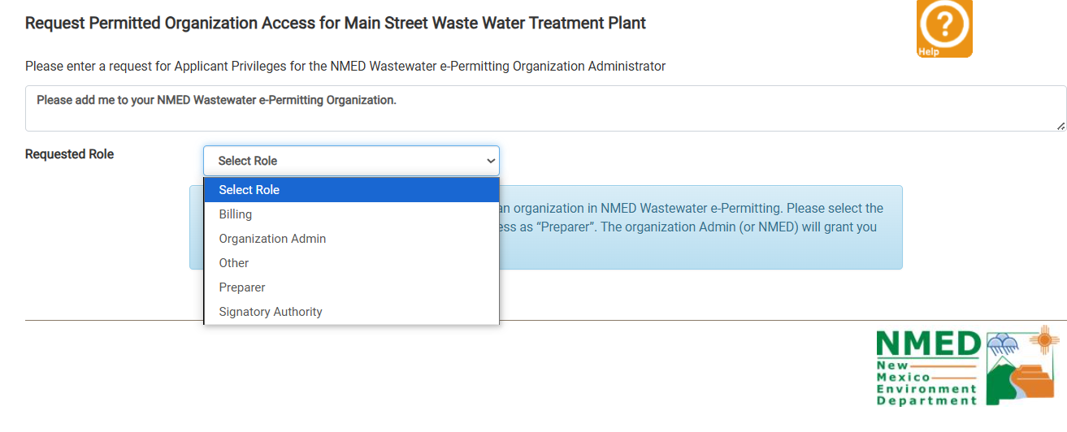
- Edit the text of the Applicant Privileges request (optional) and select your Requested Role

  - You will have to wait for NMED or someone in your organization to approve your access.

Leave an Organization
- Log into your WWeP account.
- Click on “Organization and Contacts”
- Click “Leave Organization”
